**Database Design Coursework Template**

Student Name: Yusuf Ahmed

Student ID: 240013970

Student Number: 240013970

**Scenario Topic Name:** Gaming Tournament

**Scenario**: Each team has an assigned room. Each gamer has their own setup which is unique and kept in a service room until used. This needs to be kept track of with an ID system, and a roomNo system. All rooms are uniquely numbered and have a color-coded name given (Green 45, Blue 45 are two different rooms). A team has many gamers and one gamer has a team. Teams have a unique ID and also have a rating from 0 to 5, as well as team size recorded. Qualifying teams are recorded to form new matches. Team leader is a gamer of the team. Attendees enter their information when signing up; name, phone number, email and address. All attendees have to be either a gamer or team leader when we begin the tournament. Attendees who are in a team, as either a team leader or gamer have a gamertag and a team. Each active gamer is given a code for all rooms entry, apart from service rooms, which tells management what time, and who entered a room. Team leaders have a lockout code, which is separate to their entry code, to lock a given room.

**Example queries** (Minimum 5 – list, who, which, how many, most, fewest etc. - check that your models have the attributes needed to answer the queries)

Is [yusuf@gmail.com](mailto:yusuf@gmail.com) a solo gamer?

What matches does team #456 have?

List the equipment ID of all gamers in a team

Which seat is gamertag “yusuf123” allocated to?

Is “yusuf123” at an assigned table?

**Entity Relationship Model** (insert a jpg image of your model exported from Visual Paradigm in the space below).

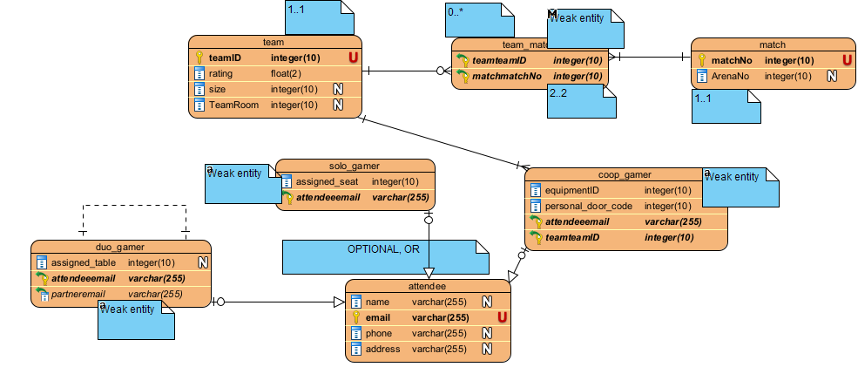

**Relational Model Tables**

* Copy and paste the table below for as many relational tables as you need
* Replace the placeholder names (table-name1, attribute-name5 etc) with the table and attribute names you derived from your ER model
* List primary key attributes first
* Add new rows to the tables (in the correct place) as needed
* Delete any unnecessary rows (attribute rows and foreign key rows if not used)
* Primary keys are to be specified in the format PRIMARY KEY (attribute-name1, attribute-name2, etc)
* Foreign keys are to be specified in the format ‘FOREIGN KEY (attribute-name) REFERENCES table-name (attribute-name)

|  |  |
| --- | --- |
| **Relational table specification** | **Marker’s corrections (Do not write in this column)** |
| **Table name:** Match |  |
| **Attributes** |  |
| matchNo |  |
| ArenaNo |  |
| **PRIMARY KEY** (matchNo) |  |

|  |  |
| --- | --- |
| **Relational table specification** | **Marker’s corrections (Do not write in this column)** |
| **Table name:** team_match |  |
| **Attributes** |  |
| teamteamID |  |
| matchNo |  |
| **FOREIGN KEY** (teamteamID) REFERENCES team (teamID) |  |
| **FOREIGN KEY** (matchmatchNo) REFERENCES match (matchNo) |  |

|  |  |
| --- | --- |
| **Relational table specification** | **Marker’s corrections (Do not write in this column)** |
| **Table name:** team |  |
| **Attributes** |  |
| teamID |  |
| rating |  |
| Size |  |
| teamRoom |  |
| **PRIMARY KEY** (teamID) |  |

|  |  |
| --- | --- |
| **Relational table specification** | **Marker’s corrections (Do not write in this column)** |
| **Table name:** coop_gamer |  |
| **Attributes** |  |
| equipmentID |  |
| personal_door_code |  |
| attendeeemail |  |
| teamteamID |  |
| **FOREIGN KEY** (teamteamID) REFERENCES team (teamID) |  |
| **FOREIGN KEY** (attendeeemail) REFERENCES attendee (email) |  |

|  |  |
| --- | --- |
| **Relational table specification** | **Marker’s corrections (Do not write in this column)** |
| **Table name:** solo_gamer |  |
| **Attributes** |  |
| assigned_seat |  |
| attendeeemail |  |
| **FOREIGN KEY** (attendeeemail) REFERENCES attendee (email) |  |

|  |  |
| --- | --- |
| **Relational table specification** | **Marker’s corrections (Do not write in this column)** |
| **Table name:** attendee |  |
| **Attributes** |  |
| email |  |
| name |  |
| phone |  |
| address |  |
| **PRIMARY KEY** (email) |  |

|  |  |
| --- | --- |
| **Relational table specification** | **Marker’s corrections (Do not write in this column)** |
| **Table name:** duo_gamer |  |
| **Attributes** |  |
| attendeeemail |  |
| assigned_table |  |
| partneremail |  |
| **FOREIGN KEY** (attendeeemail) REFERENCES attendee(email) |  |
| **FOREIGN KEY** (partneremail) REFERENCES duo_gamer(attendeeemail) |  |

**Marker’s Comments** (Do not write in this section)

**Important:** Please note that marker’s corrections to your relational tables are there to help you construct a working database for the second coursework. They are not the determinant of your mark. For more information on how your work is assessed see the coursework specification and grade related criteria.

**Business Scenario and Queries:**

* The business scenario you submitted as database modelling coursework is not clear from a description point of view.

* Your queries are acceptable and implementable in your database design.

**Entity Relation Diagram (ERD):**

* Your coursework demonstrates an excellent understanding of database design's fundamental principles and showcases your ability to apply them effectively. The generalization method has been used appropriately, with participatory and disjoint constraints correctly applied in your entity-relationship model, fields/attributes judiciously inherited from the parent entity, and primary keys correctly inherited from the parent entity.

* Your ERD model incorporated some of the features introduced in our lecture and tutorial exercises, displaying your ability to apply learned concepts.

However, there are several issues:

1. The relationship of duo_gamers is not recursive it just splits the gamers in pairs.
2. The subclasses are not fully done correctly. Coop_gamer has incorrect primary key. It should be the same as the superclass.
3. Coop_gamer has EquipmentID while Equipment entity is not present. It will be very complicated to use such a database.
4. The types sometimes are too large. For example, size contains 10 digits.

**Entity Relationship Mark:**

Given the above issues mentioned above, you would get 69/100.

**Relational Model Feedback and Mark: 15/20**

**The subclasses do not have primary keys.**

**Coursework Mark** (100 marks available): 70**.20**